If You’re A Trainer – You’re Out On The Edge
Keep Ahead of the Curve With Trainer’s EDGE

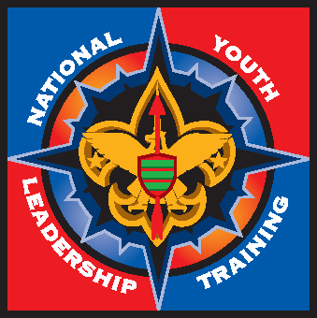
Trainer’s EDGE helps develop the skills of a trainer. It focuses on the participant raising their individual trainer skill levels. Highly beneficial for all trainers, Commissioners, Pow Wow staff and others.
Trainer’s Edge is now the required train-the-trainer course for Wood Badge and NYLT staffs.
Saturday, February 21, 2009
Virginia United Methodist Conference Center
10330 Staples Mill Road, Glen Allen, VA
8:00 a.m. – 5:00 p.m.

Handouts, lunch, snacks and a full day of great training experiences
+ Loads of fun! For a fee of only $10.00.

For Questions or Directions Contact:
Chris Habenicht, chablaw@aol.com (804) 288-5634
Rick Bragga, photoeagle@comcast.net (804) 615-0470
Nancy Fonseca, nfons@comcast.net
Lloyd Dunnavant, LloydDunnavant@comcast.net (804) 833-8335 (Cell)

Advanced Registration Required – Deadline February 14, 2009
Register on-line at www.scoutingvirginia.org
Go to the calendar - February 21 – and then click on the link to sign-up

